Component Creation from Scratch

So basically we use many components… Today lets see how to create a component.

So we have to first navigate to

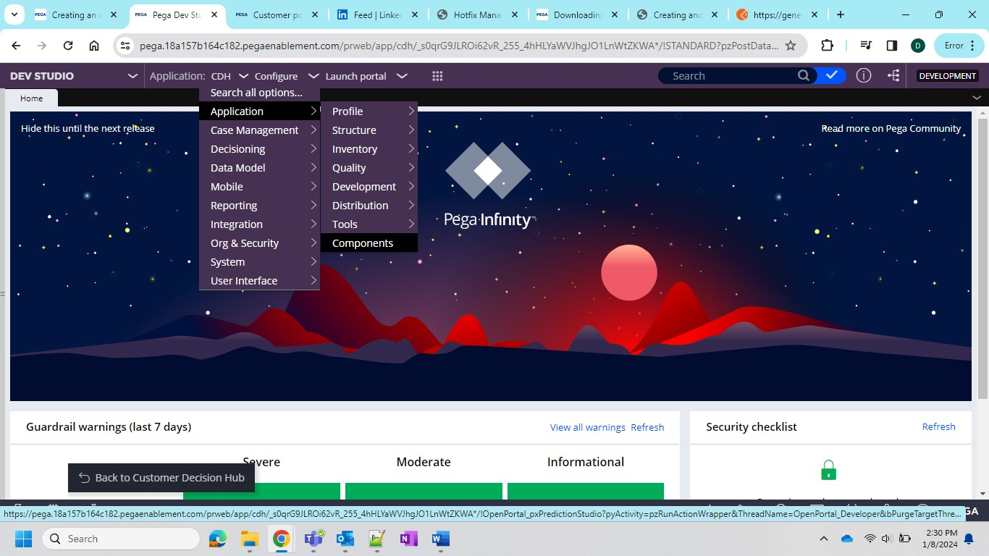

Then components page loads and looks like this

And then we have to go for creating one rest integration and steps are as follows

After the creation note down the ruleset.

In my case GeminiAIComponent and now come to the component and click on the new component creation and now add the ruleset which was created during rest integration. You can also add rulesets which you want to add in the component.

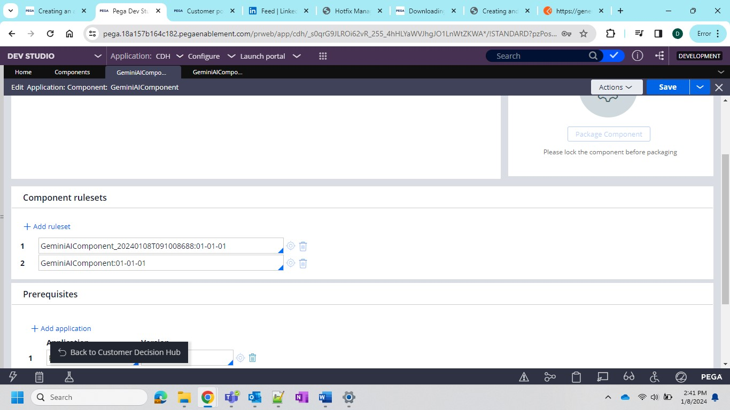

After that you should lock all the rulesets that you included in the component

And after that you have to lock the component in order to package it

And then click on Package Component

And then you can click on Download and hurray your component is ready…